TTS Converter Tech Notes

# Install FileZilla (or other SFTP client)

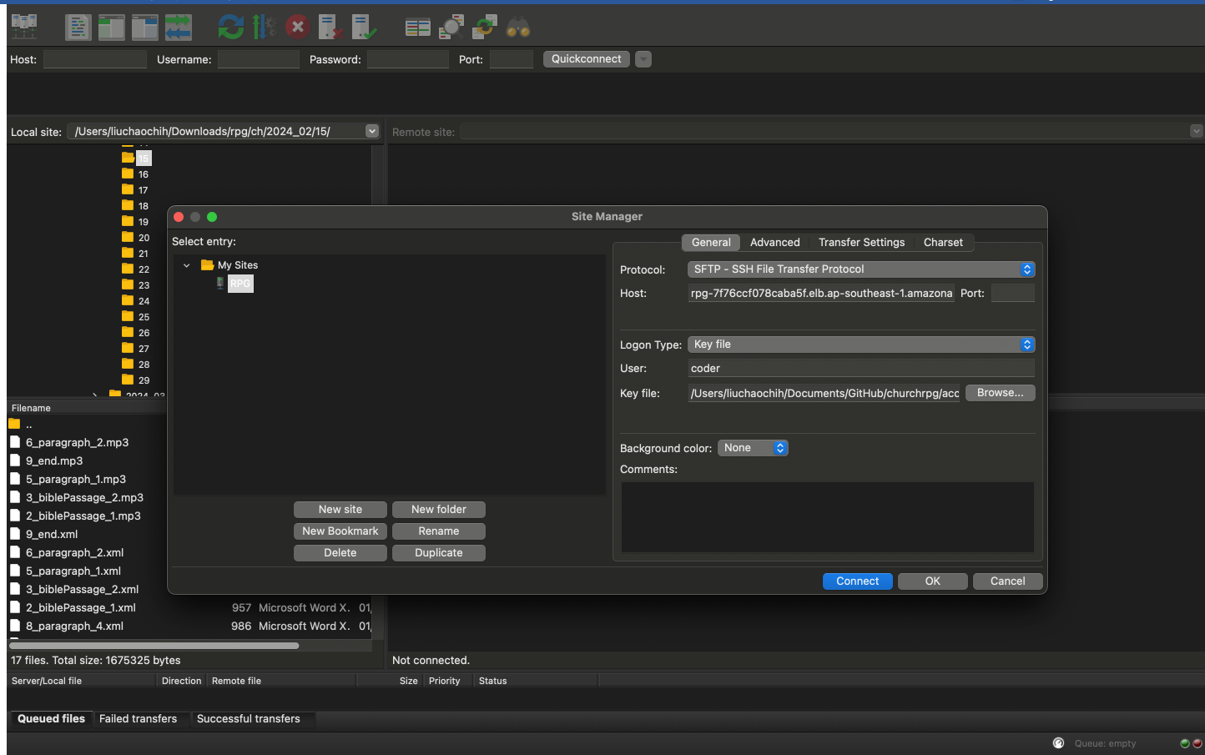

3. choose SFTP in ‘Protocol’.

Host: rpg-7f76ccf078caba5f.elb.ap-southeast-1.amazonaws.com

User: coder

logon Type: Key File

Key file: your path to save this key

2.click new site

1. Click this button on top-left corner

# Folder structure

|  |  |  |
| --- | --- | --- |
|  | Folder | Service |
| cpbpc-bible-reading-plan | 2-year bible reading plan |
| cpbpc-rpg-audio | RPG audio files |
| cpbpc-rpg-script | AI transcripts |
| cpbpc-tts | CUVS/Daily remembrance audio |
| cpbpc-tts-script | CUVS/Daily remembrance transcript |
| cpbpc-tts-us-east-1 | KJV audio |
| cpbpc-tts-script-us-east-1 | KJV verses transcripts |

# How to fix English/Chinses audio

upload changed transcript back

Correct Pinyin/IPA in transcript

Check Error and find script

Final audio merged

upload audioMerge file

Check audio files generated

# Check error and find transcript

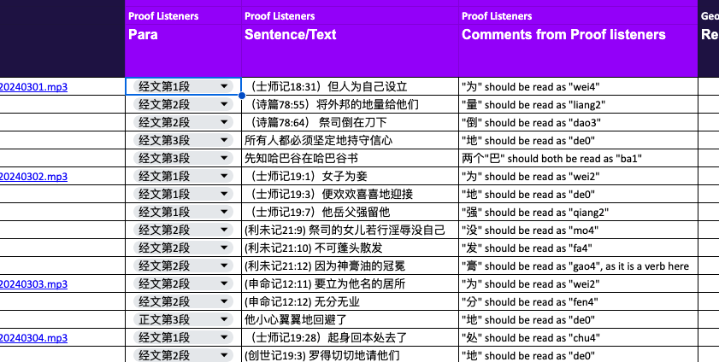match the date (from name of mp3), paragraph and sentence, should be enough to find correct transcript:

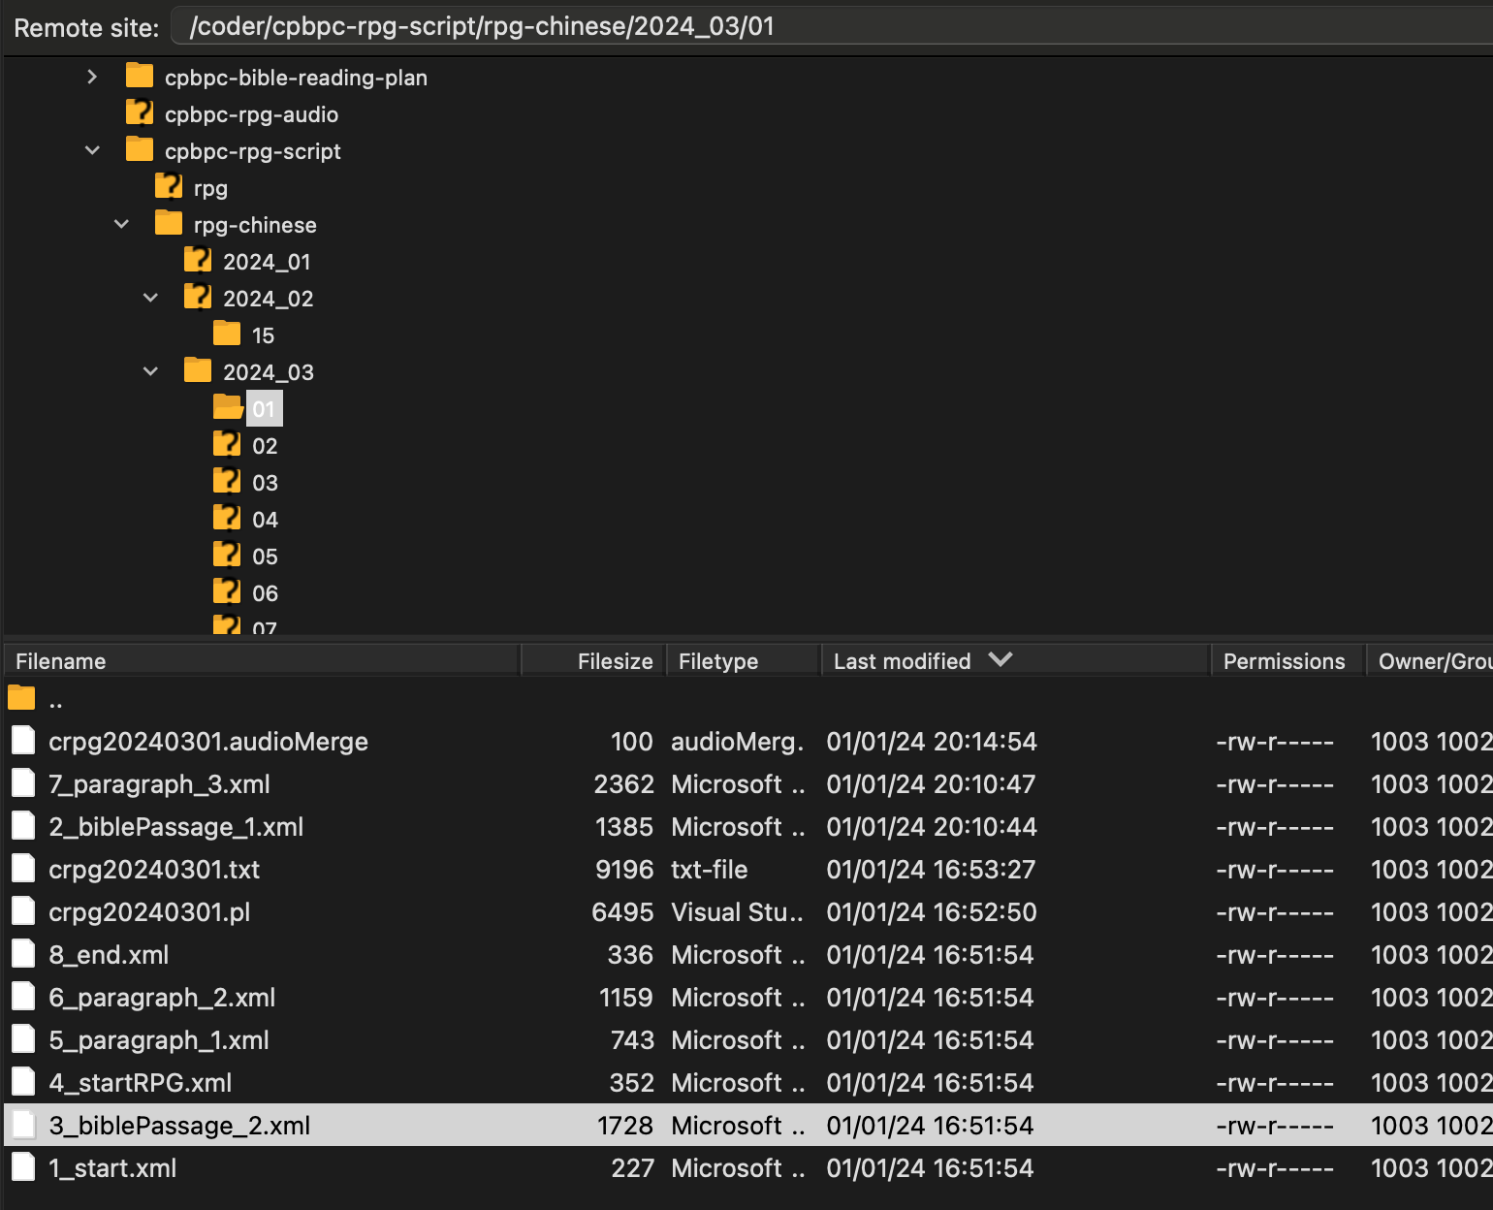

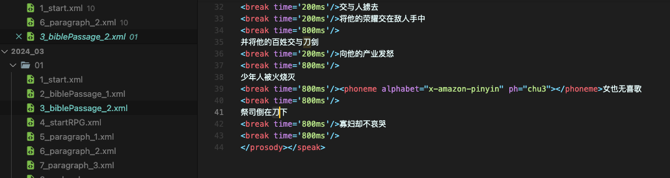

from the comment of proof listener, should be able to find correct pinyin.

# Correct Pinyin/IPA in transcript

ChatGPT can help you

English:

<phoneme alphabet='ipa' ph='ˈmæləkaɪ'></phoneme> chapter 3 verse 16 to 18

always ‘ipa’

***20240212:*** Now we have more feedback about wrong Hebrew name reading, I know we cannot make it perfect, but have to be more creative in IPA. I use 2 examples to explain my current approach to fix IPA:

1. Pison (Gen 2:11), if you use ChatGPT, probably you get this answer : paɪsən

Comparing to blue letter audio Bible, there is a big difference. Can we try ˈpɪsɒn instead?

1. Gihon (Gen 2:13), ChatGPT gives ˈɡaɪˌhɒn, but ˈɡɪ.hɒn seems a better answer.

If you look at these 2 examples above, its not difficult to see IPA alphabets are not typical English letters. It should not be a problem for you (I believe Singaporean is native English speaker) to find correct pronunciation with your ears, but finding correct alphabets and testing are problems. So I will give you my database, which contains my current attempts, and you can copy-paste those alphabets. Also, here are 2 websites, I hope they can help converter’s work:

<https://www.internationalphoneticassociation.org/content/full-ipa-chart>

<http://ipa-reader.xyz/> (for test, you can choose ‘British Amy’ and try)

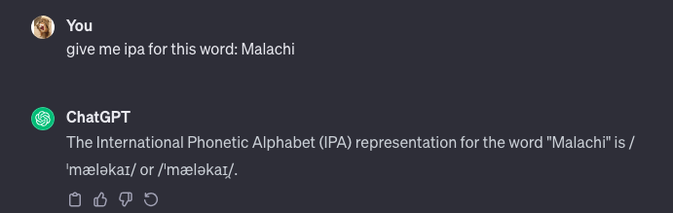

Chinese:

check with listeners’ comment

AWS syntax:

~~<phoneme alphabet="x-amazon-pinyin" ph="di4"></phoneme>~~

don’t just write ‘pinyin’

***20240212:***  We have changed to Microsoft Azure from AWS, just for Chinese materials. Reasons are two:

1. More voice options
2. finally, unwanted pauses can be eliminated with Azure.

Chinese word, optional, but good to have it

Azure:

<phoneme alphabet="sapi" ph="sa 1">撒</phoneme>

exactly 1 whitespace between pinyin and intonation

use ‘sapi’

How to eliminate unwanted pause:

你和你父家<phoneme alphabet="sapi" ph="bi 4 yong 3 yuan 3">必永远</phoneme>行在我面前

We can put fixes for multiple words together, but be careful of the syntax above. And it’s the way to remove pauses, Azure AI can evaluate combination before whole sentence, so pauses can be removed.

# Upload changed transcript back

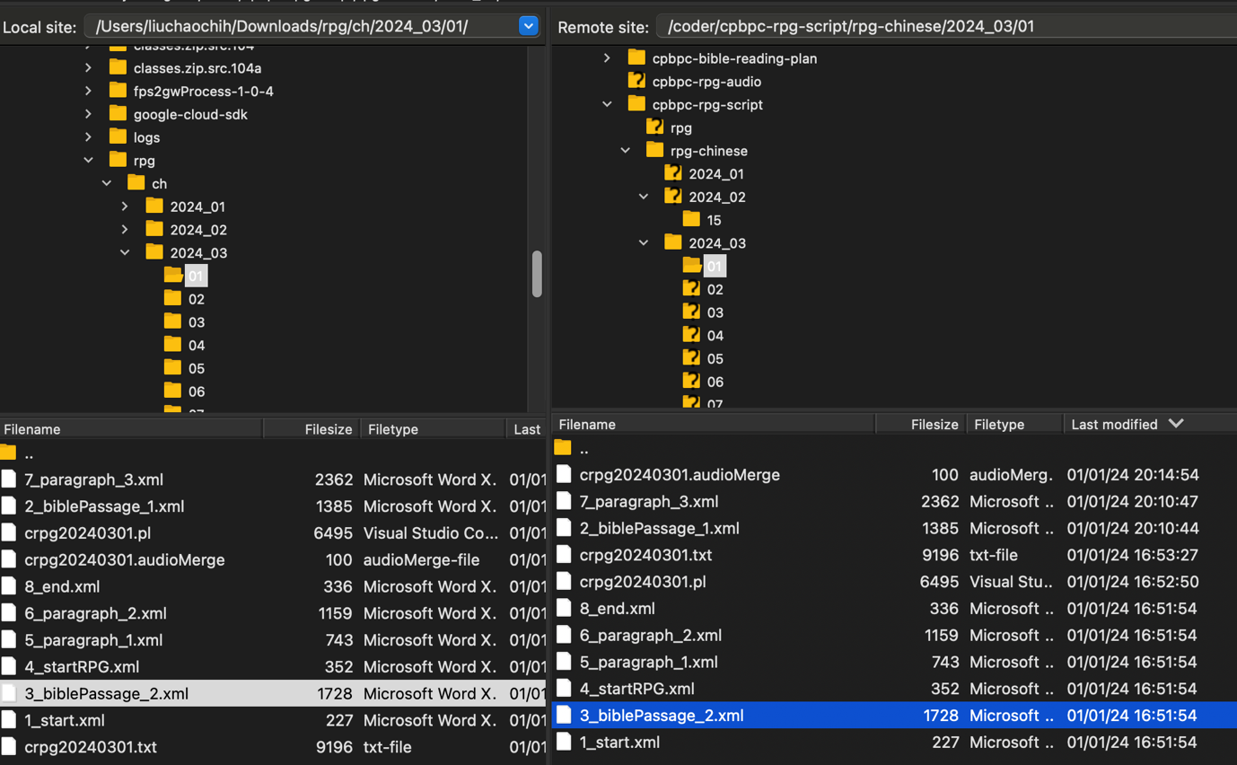

upload back to original place. Come back to audio folder and check ‘Last modified’ timestamp:

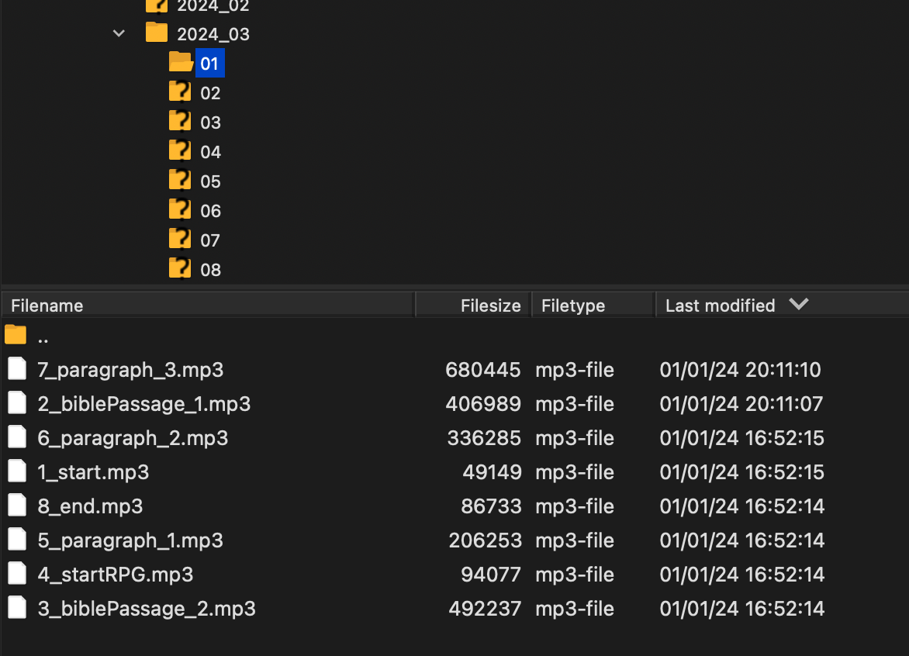

# Merge final audio

If new clip audio is ready, have to merge all parts of audio into complete mp3 file:

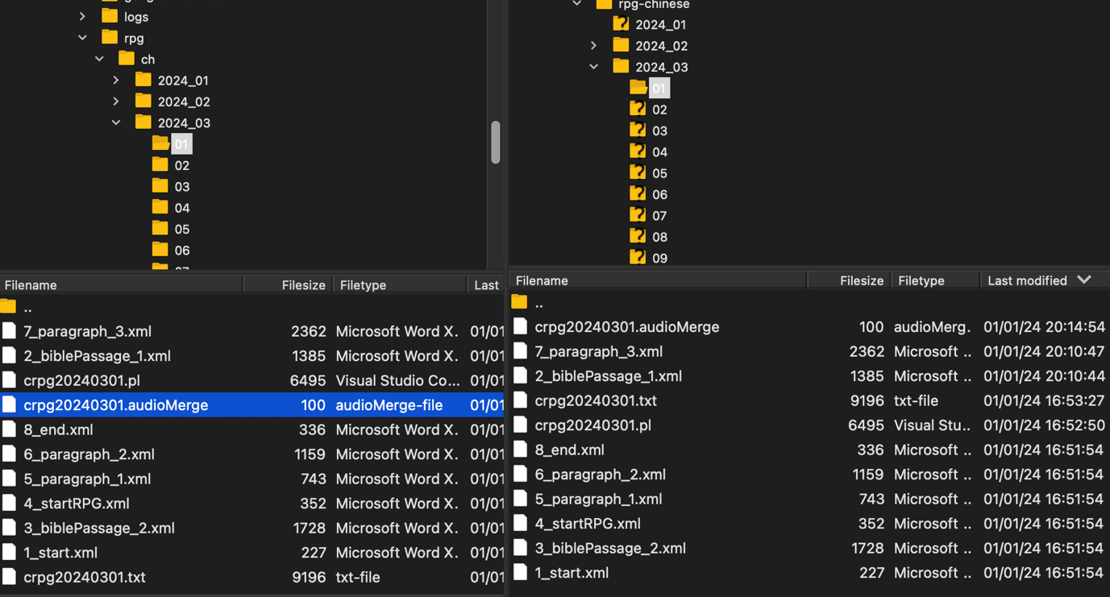

just upload .audioMerge file to original place, don’t need to change content.

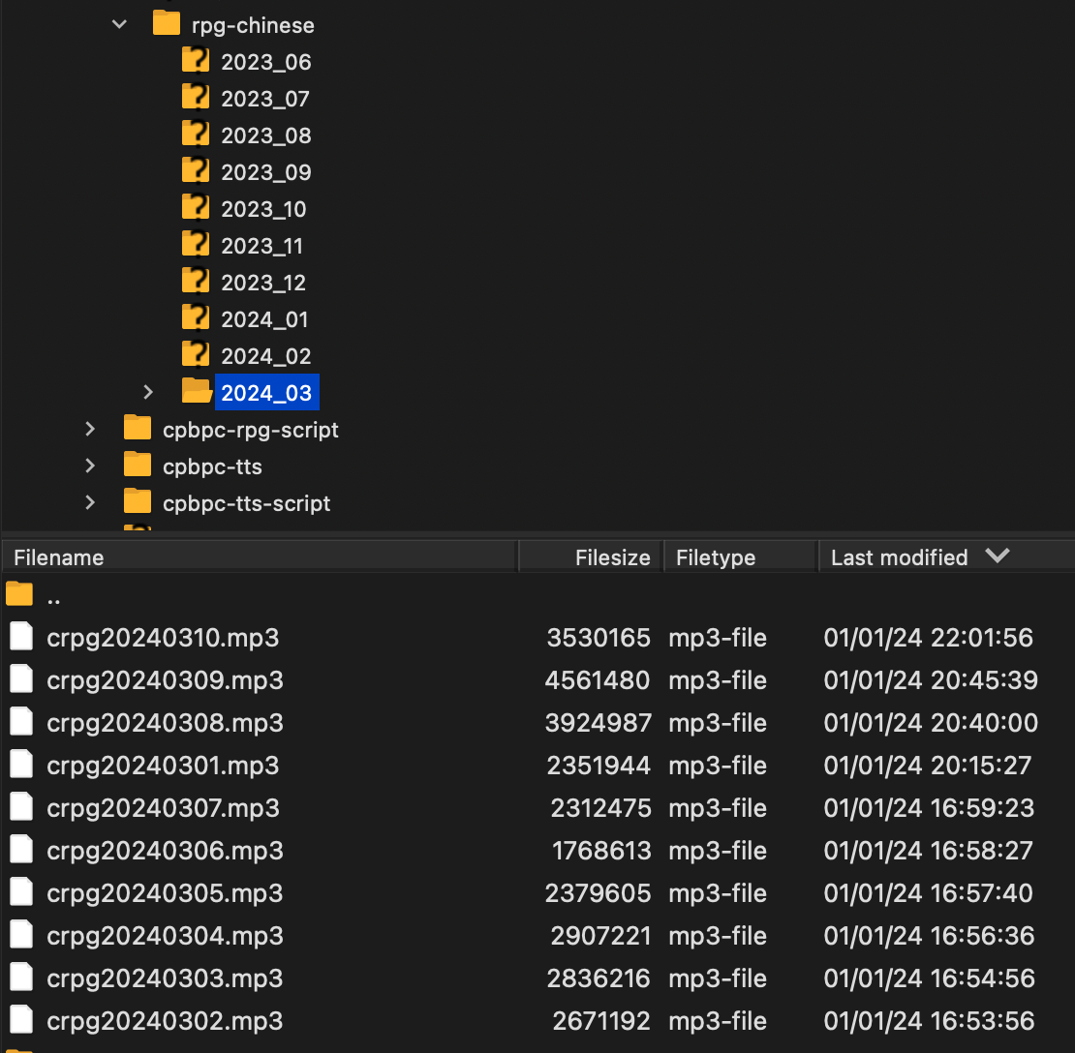

come back to audio folder, check timestamp of last modified.

Finally! give your comment and tell listeners its fixed.

